Oklahoma State University
Office of the Associate Vice President and Controller
207 Whitehurst
Stillwater
OK 74078

(405) 744-4188

http://controller.okstate.edu

Self-Service Banner (SSB)
Finance Training Workbook

Notice of rights© 2012 Ellucian. All rights reserved. Contains confidential and proprietary information of Ellucian and its subsidiaries. Use of these materials is limited to Ellucian licensees, and is subject to the terms and conditions of one or more written license agreements between Ellucian and the licensee in question.

Table of Contents

1. Introduction 2
1.1 access 2
1.2 Document Completion 2
1.3 SSB-Finance Forms 2
1.4 Features 3
1.5 FOAPAL Codes Look Up 3
1.6 Chart Elements 3
1.7 Saving Templates 4
1.8 Save As Warning 4
2. Accessing SSB-Finance 4
3. Code Lookup Function 7
AIRS Banner Crosswalks 8
4. Performing a Budget Query 10
4.1 comparison queries 10
4.2 Downloading Query Data to a Spreadsheet 11
4.3 Saving Queries as Templates 11
4.4 User-Calculated Columns 11
4.5 Budget Status by Account 12
4.6 Budget Status by Organization Hierarchy 12
4.7 Budget Quick Query 13
4.8 Payroll Detail in Budget Queries 14
4.9 Performing an Encumbrance Query 18
4.10 Encumbrance summary report 18
5. Document Accounting Distributions Screen 18
6. Viewing Documents 20
7. Performing a Budget Transfer 25
8. Performing a Multiple Line Budget Transfer 27
9. Delete Finance Template 29

Introduction
This workbook is an introduction to the functions of Self-Service Banner (SSB) - Finance which allows users to:

- query budgets
- query encumbrance data
- create Finance templates
- approve documents
- view documents
- create budget transfers
- create multiple line budget transfers
- delete Finance templates.

access
The access to the forms and queries granted to each user is controlled by the implementation of the standard Finance Fund/Organization and Rule Class Security in Banner. Once either or both of these security measures are turned on in Banner, SSB-Finance recognizes them, thus granting appropriate access to the user.

Document Completion
The successful completion of a document created through SSB-Finance will require:
- Available budget at time of entry.
- Once an entry form is initiated, it must be completed. Entry forms cannot be left in process or all information will be lost.

SSB-Finance Forms
SSB-Finance provides four query forms and five entry forms:

- Budget Query by Account
- Budget Query by Organizational Hierarchy
- Budget Quick Query
- Encumbrance Query

- Approve Documents
- View Document
- Budget Transfer
- Multiple Line Budget Transfer
- Delete Finance Template

Features
SSB-Finance provides “look-up”, template management and “warning” features to easily find information and create efficiencies within the Banner Finance database:

- FOAPAL Codes Lookup
- Saving/Deleting Templates
- Save As Warning

FOAPAL Codes Look Up
SSB-Finance forms allow users to look up different codes related to a specific chart of accounts within Banner.

Chart Elements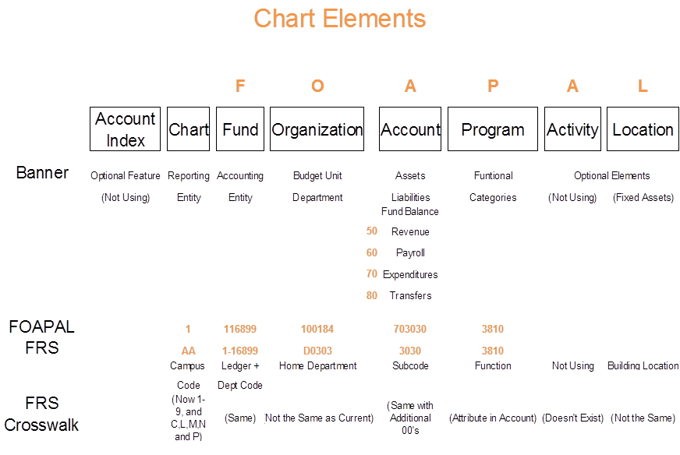

Saving Templates
- The Finance forms and queries provide users the option to save completed transactions and queries for future use. There are two types of queries:

  - Personal (retrievable by user only)
  - Shared (retrievable by any user).

- Once the form or query is saved as a template, it can be retrieved at any time and the information or parameters can be changed.

- A user can use the Delete Finance Template link to delete their personal templates or queries.

Save As Warning
Users have the option to save web-completed SSB-Finance forms or query as a personal or shared template for future use. To prevent accidental overwrites of existing templates, SSB-Finance delivers the “Save As” warning message to interrupt a potential unwanted save.

Accessing SSB-Finance
Steps to Complete this Process

- Enter the URL address of SSB-Finance https://osuportal.okstate.edu
- Enter your O-Key username and password and click Login

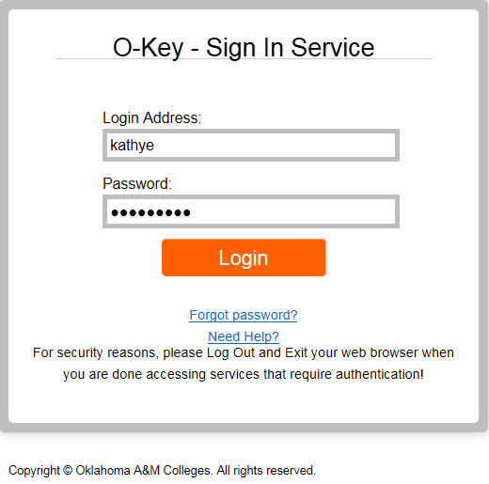

From the Main Menu, click Finance to access the Finance Menu.

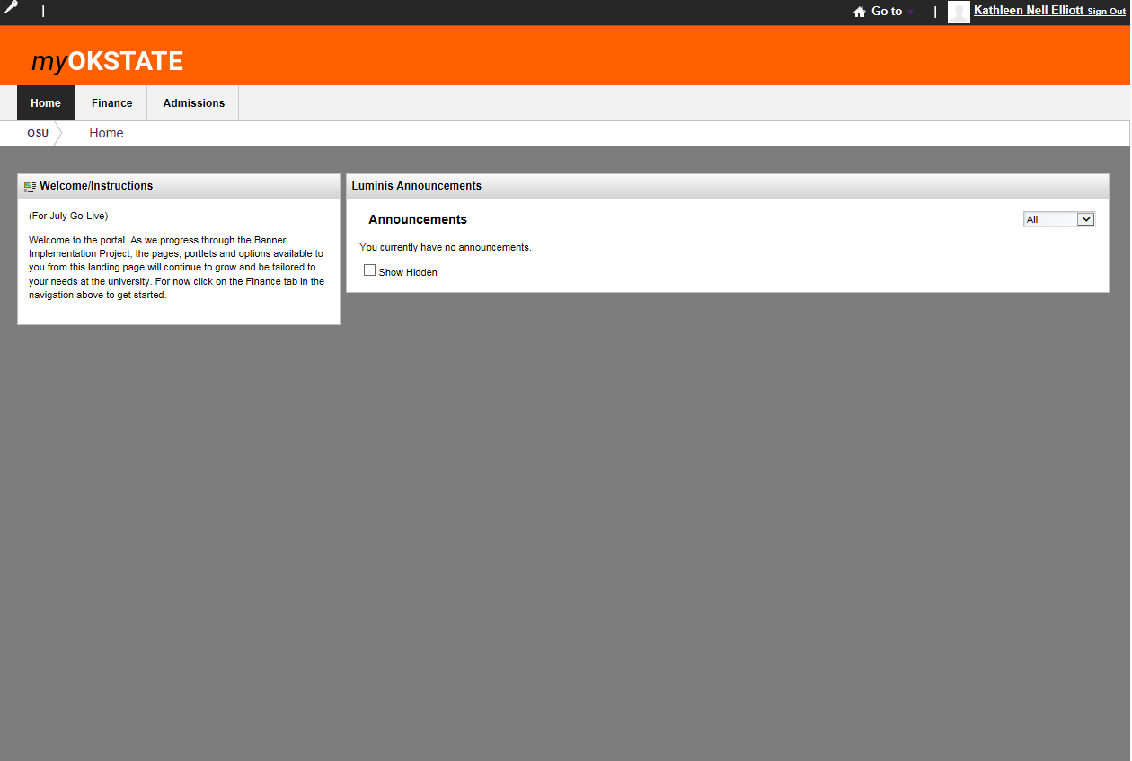

- Click on SSB under Applications/Links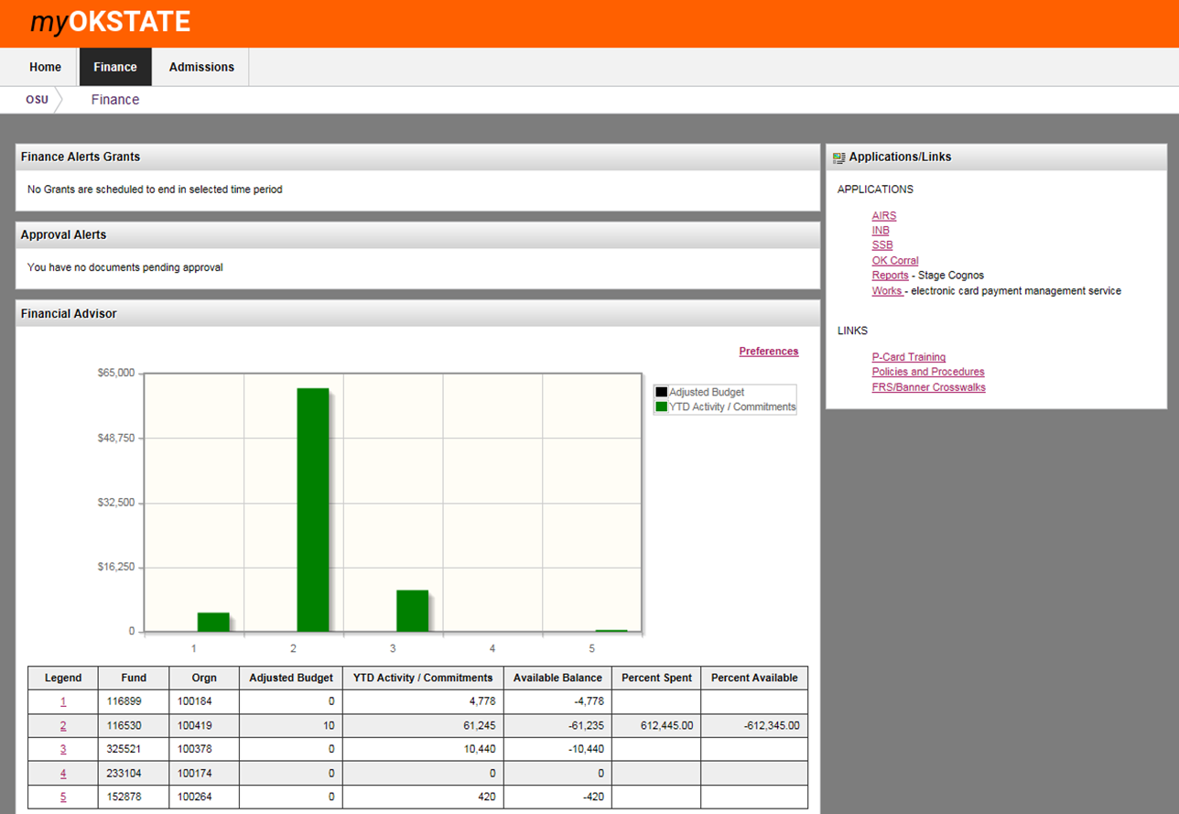

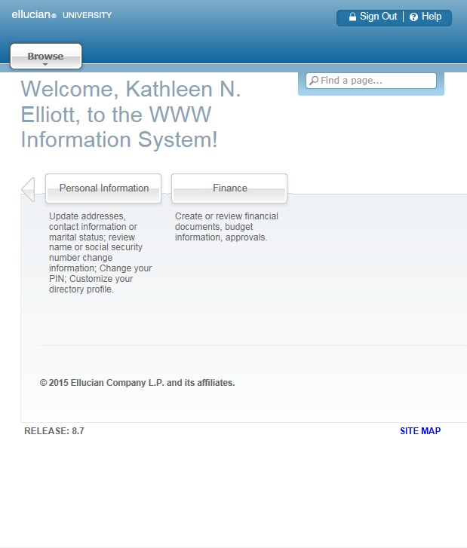
- The Finance Menu contains these options

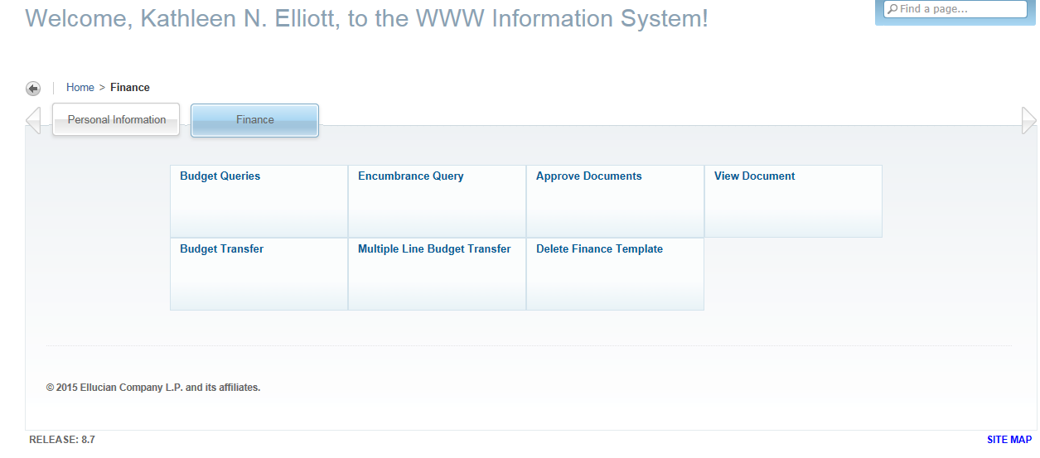

Code Lookup Function
The Code Lookup function is attached to some options from the Finance Menu (Budget Transfer, and Multiple Line Budget Transfer).

Steps to Complete this Process

- Select Budget Transfer from the Finance Menu.
- Scroll down to the Code Lookup section near the bottom of the page.
- Select a Chart of Accounts Code from the drop-down menu.
- Use the Type drop-down menu to find the value you want to query.
- For this exercise, select fund.
- Enter the wildcard % in the Code Criteria field.

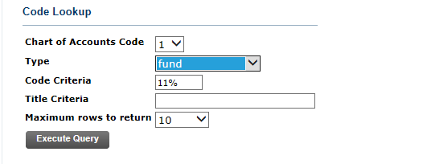
Click the Execute Query icon to view the List of Values. The page will refresh and display the results of your query

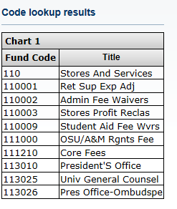
You can select up to 10000 rows.

OR….

AIRS Banner Crosswalks
Go back to your Banner Portal tab and click on FRS/Banner Crosswalks

and click on FRS/Banner Crosswalks
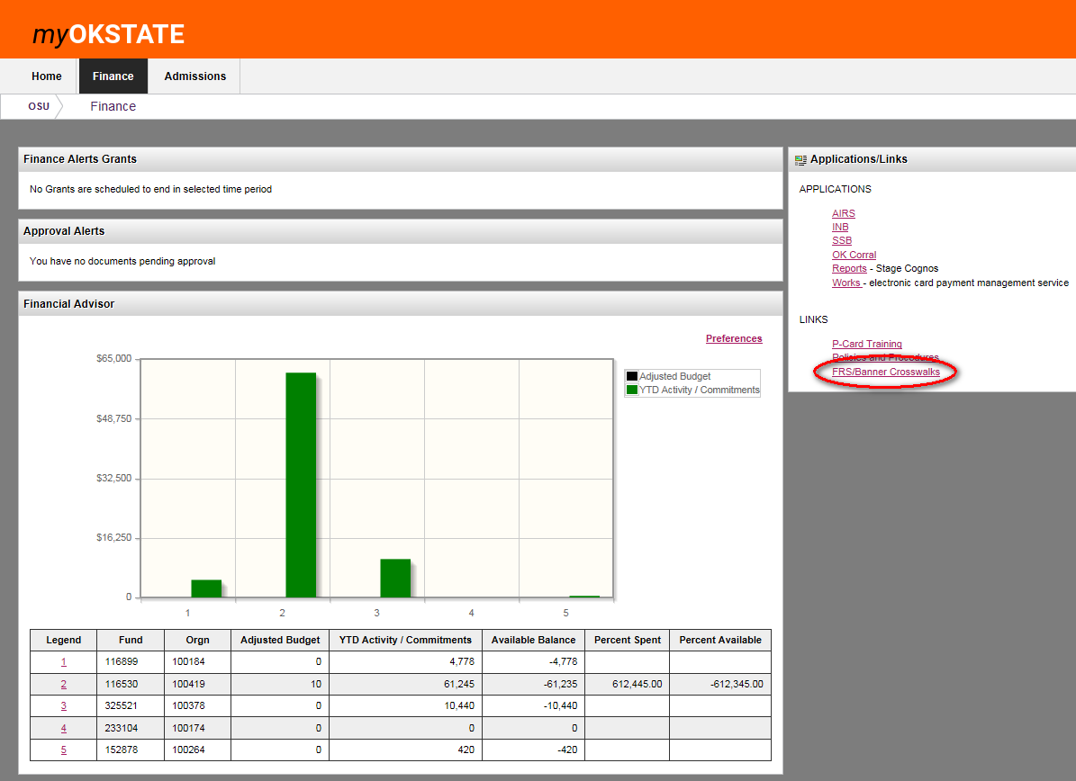
If you are not already logged into AIRS, it will take you to the AIRS Menu Page and Banner Crosswalks is under Other.
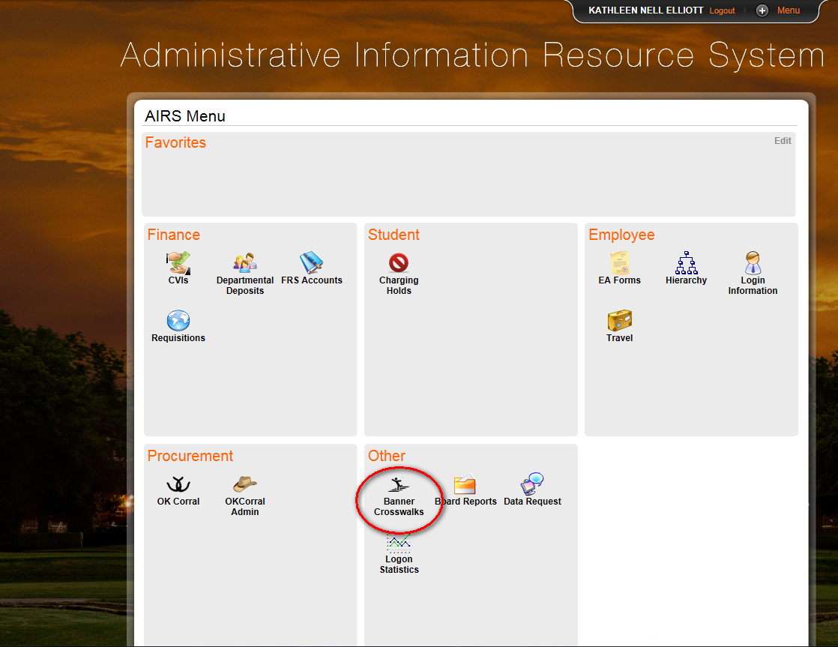
If you are already logged into AIRS, it will take you directly to Banner Crosswalks, enter the component you wish to search on, click search, and…
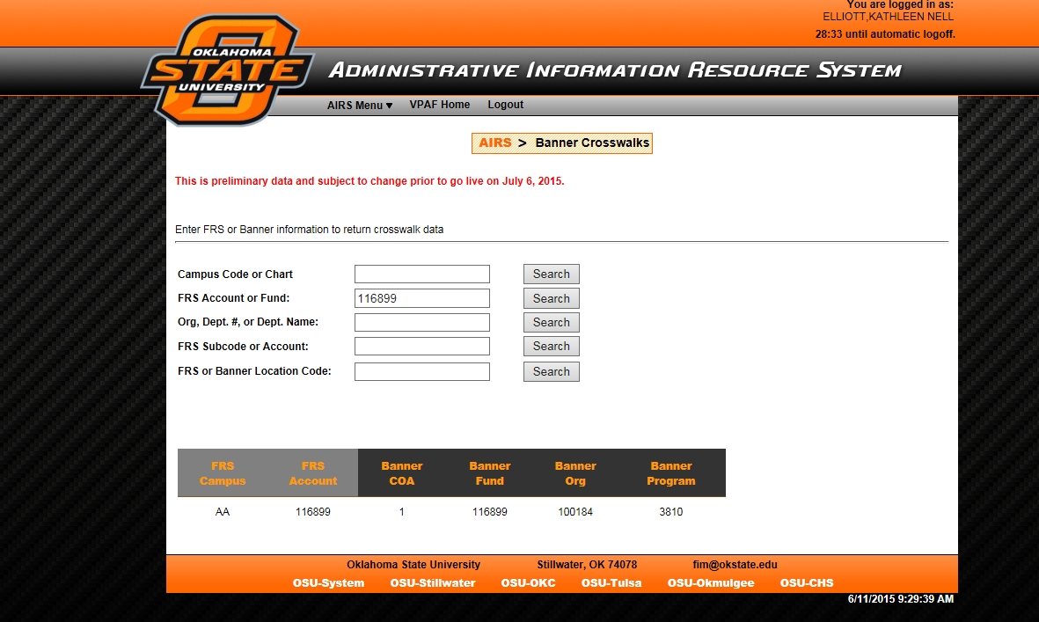
the FOAPAL information will be provided.

Performing a Budget Query
The Budget Query option permits the SSB-Finance user to access Budget Status information. Users can also review the payroll labor distribution information by either drilling down from the Budget Status by Account or using the Payroll Detail in Budget Queries. The data selected through a SSB-Finance query can be downloaded to a Microsoft Excel spreadsheet.
A user may build or retrieve these types of queries:
- Budget Status by Account
- Budget Status by Organizational Hierarchy
- Budget Quick Query
- Payroll Expense Detail

Users may choose from the following Operating Ledger Data for Budget Status by Account and Budget Status by Organizational Hierarchy:
- Adopted Budget
- Budget Adjustments
- Adjusted Budget
- Temporary Budget
- Accounted Budget
- Year to Date
- Encumbrances
- Reservations
- Commitments
- Available Balance

comparison queries
When users choose their desired parameters, they may select one fiscal period and year fro comparison to the required fiscal period and year. (Budget Quick Query only shows one fiscal year). With this selection, all the details that are retrieved will be placed next to the corresponding comparison fiscal period.

Downloading Query Data to a Spreadsheet
Users can download budget query data to a Microsoft Excel spreadsheet and then edit it, according to their reporting needs.
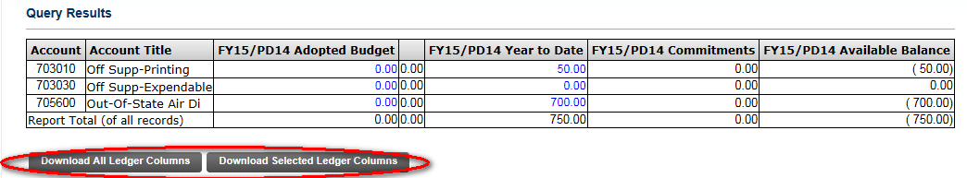

Saving Queries as Templates
A query can be saved as a template on each screen. However, each time a query is saved, only the information entered and queried up until that point is saved. A user can enter a query and save it on each screen under a different name, creating several templates, each with its own detail or path.
This functionality enables the user to save the query and retrieve it later for quick reference or customizing. Queries may be saved as ‘Shared’ or ‘Personal.’ Other users may access ‘Shared’ queries; ‘Personal’ queries may be accessed only by the user who created them.
Note: You can use the Delete Finance Template link to delete your personal templates.

4.4 User-Calculated Columns
The detail screen provides the capability to add “user calculated columns” to a query. This allows the user to add, subtract, multiply, divide, or get a percentage of any two operating ledger columns, choose where they should be displayed, and name them. These columns may be removed, saved, or added from a query or template at any time.
Note: The user calculated columns cannot be downloaded into Excel because they are just calculations.

Budget Status by Account
The Budget Status by Account option allows a user to review budget information by account for the fiscal period, year to date, and commitment type by:
- Specific FOAPAL/Index values
- A Specific Organization
- All Organizations
- Grant
- Fund Type
- Account Type
- Revenue Accounts.

There are five levels to a Budget Query by Account:
- Account Detail
- Transactions Detail
- Document Detail
- View the Document
- View Payroll Expense Detail

Budget Status by Organization Hierarchy
The Budget Status by Organization Hierarchy option allows users to review budget information for organizations:
- Hierarchical Structure
- Specific Funds, High-level Organizations, Accounts, and Programs
- Fund Type
- Account Type
- Revenue Accounts

The levels of this type of query include:
- Organizational Hierarchy
- External Account Type (Levels 1 and 2)
- Account Detail
- Transaction Detail
- Document Detail
- View the Document

Budget Quick Query
The Budget Quick Query is used to review budget information by adjusted budget, year to date, commitments, and available balance by:
- Specific FOAPAL/Index values
- A specific organization
- All organizations
- Grant
- Revenue accounts.

The levels of this type of query do not allow any type of query for: Account Detail, Transaction Detail, Document Detail, or View the Document.

Payroll Detail in Budget Queries
The Payroll Detail in Budget Queries option allows a user to review the payroll labor distribution information by account for the fiscal year and fiscal period by:
- Specific FOAPAL/Index values
- A Specific Organization
- All Organizations
- Grant
- Fund Type
- Account Type
- Revenue Accounts

Note: For a Payroll Expense Detail query to be successful, a user with Fund Organization query access and Payroll Detail access must enter a value in either the Organization or Grant fields as well as the Fiscal Year, Period, and Chart of Accounts fields. If grant information is queried, all retrieved information is grant inception to date. Otherwise, all information retrieved is through the fiscal year to date.

Steps to Complete this Process:

Click Budget Queries from the Finance Menu to navigate to the Budget Query Page.

Under Create a New Query, click the drop-down Type menu to view values.

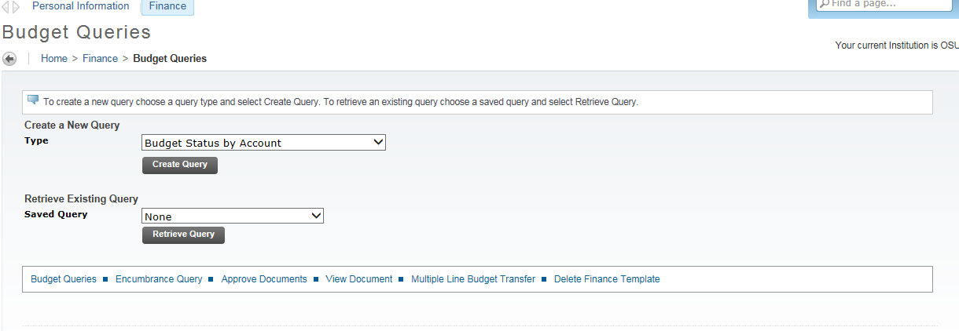
Select Budget Status by Account to view budget information
Select Budget Status by Account to view budget information for organizations detailed by account. You may wildcard either or both the organization or account (as well as other values, except chart). This does not work with hierarchical organization or account codes.
Select Budget Status by Organizational Hierarchy to view summarized budget information using actual or hierarchical organization or account codes.

Enter a name for your query in the Save Query As field.

Note: Do not use the following non-standard characters in your query name. They are the semicolon (;), slash (/), ampersand (&), at sign (@), and question mark (?).

Check the Shared checkbox.

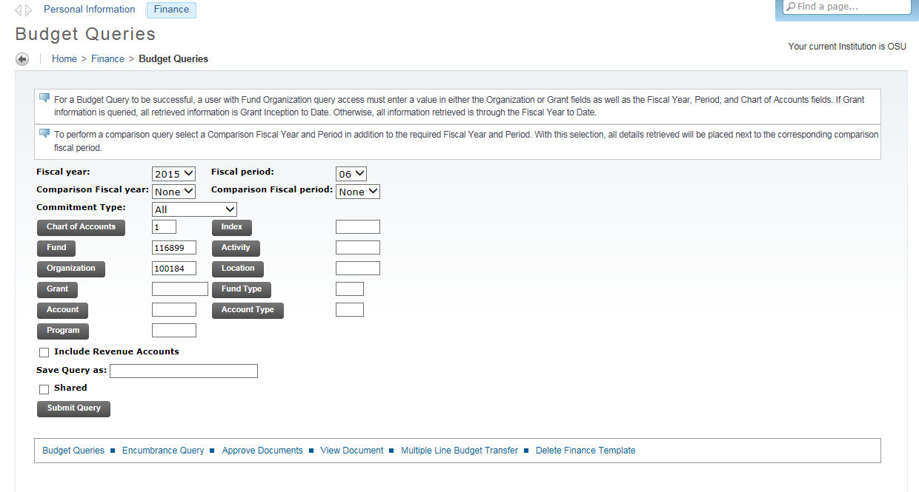
Select Budget Quick Query to view summarized budget information for organizations. This does not work with hierarchical organization or account codes.
Select Payroll Expense Detail to view the entire payroll distribution data for the Fiscal year and Fiscal period.

After selecting a query type, click the Create Query icon.

Check the appropriate checkboxes for your query.

Click the Continue button.

Enter the appropriate parameters for your query.

Note: You must choose either a valid organization or a valid grant and chart of accounts to retrieve any data.

Save Query as ________________ to save the entire query for reuse.

10. Check the Shared checkbox.

11. Click the Submit Query button.

12. The page will refresh and display the results of your query, along with the parameters that were selected.

13. Click the View Pending Documents button if pending documents exist.

14. The page will refresh and display the Status of Transactions in Process page.

Performing an Encumbrance Query
The Encumbrance Query feature of SSB-Finance allows users to review outstanding Encumbrance information. Users may enter any FOAPAL values to narrow their query. Users must also populate the Organization or Grant fields to submit a query, though wildcards are permitted in these fields. Remember that access is controlled by Fund/Organization security.

Encumbrance summary report
Once the parameters are selected for a particular query and submitted, the Encumbrance query brings back information on the related encumbrances by account. The report displays the following information: Fiscal period, Chart of Accounts, FOAPAL elements, Account, Document Code, Description, Encumbrance information and amounts, Percentage used, and totals.

Document Accounting Distributions Screen
The following information is displayed on the Document Accounting Distributions page:
- Fiscal period
- Chart of Accounts
- Document number, date and code
- Transaction description
- Rule class
- Encumbrance information and amounts
- Item and sequence numbers
- FOAPAL

Steps to Complete this Process:

- Click on Encumbrance Query from the Finance Menu to navigate to the Encumbrance Query Page.

Enter appropriate parameters or retrieve an existing query.

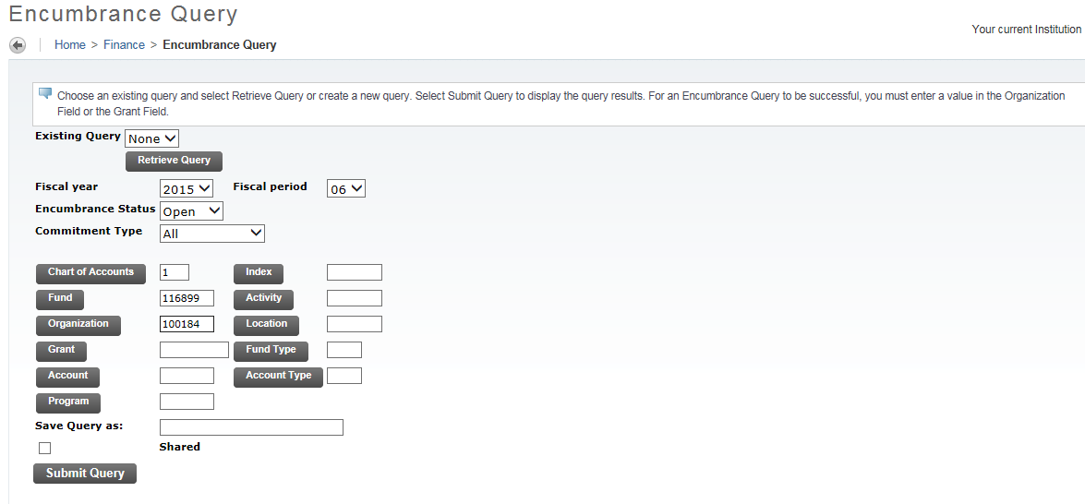

- Click the Submit Query button.

Viewing Documents
SSB-Finance allows a user to view detail information about a document (completed items from OK Corral that have gone through the entire workflow such as requisitions, purchase orders, invoices, and also journal vouchers, encumbrances, or direct cash receipts). Any existing Banner document may be retrieved and viewed by this means.
You can submit a document query by:
- document type
- document number
- submission number
- change sequence number

Steps to Complete this Process:

- Click on View Document from the Finance Menu to navigate to the Document Page.
- Enter a document number in the Document Number field.
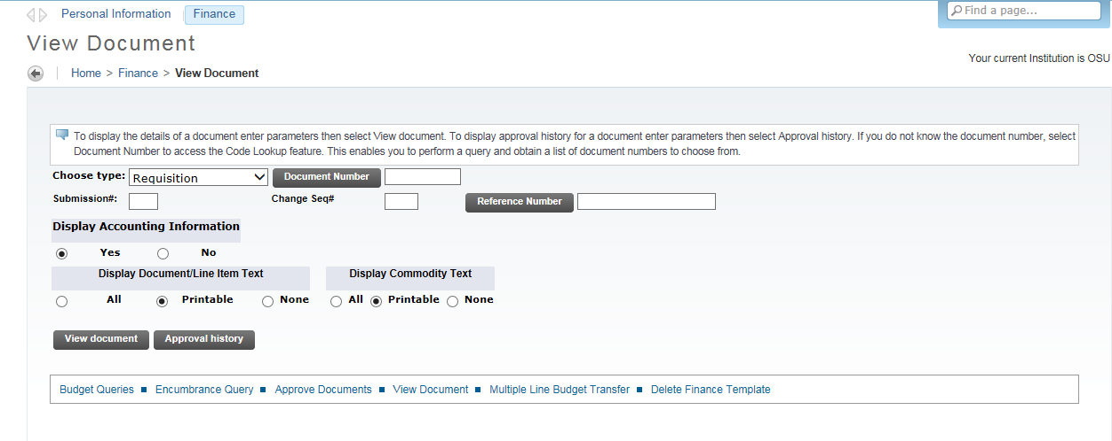
Note: You can enter a document number from an external system, such as OK Corral, in the Reference Number field.

- Click the View Document button to view that document.

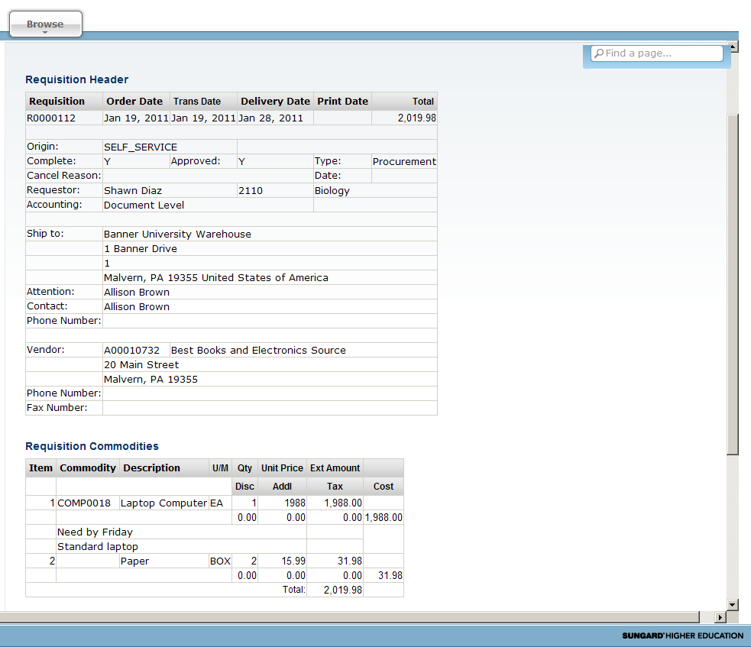

4. Click the Approval History icon to view the document's properties.
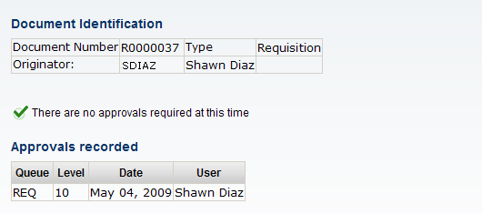

- If you wish to browse through documents of a specific type, select it in the Choose Type field and click the Document Number button to navigate to the Document Lookup field.
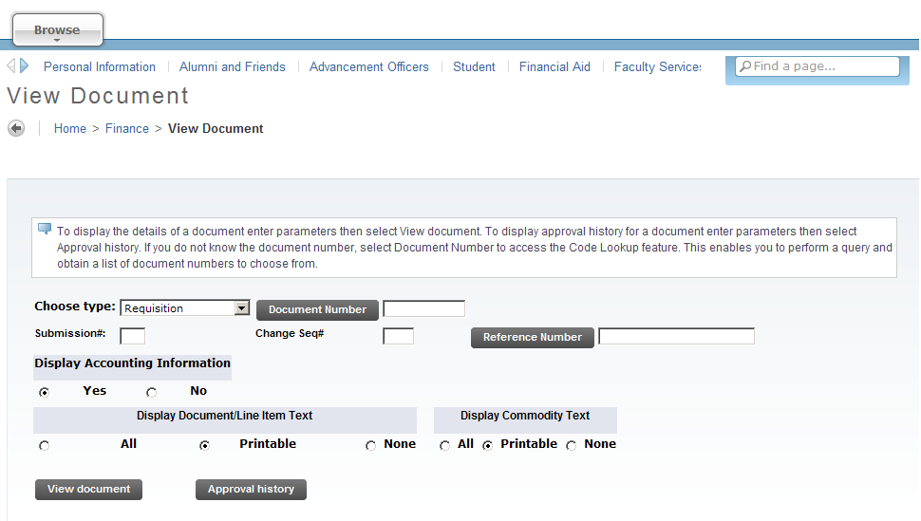
- Enter the desired search terms in the fields, and click the Execute Query button to generate a list of all matching documents. At least one of the starred fields is required to execute a query.
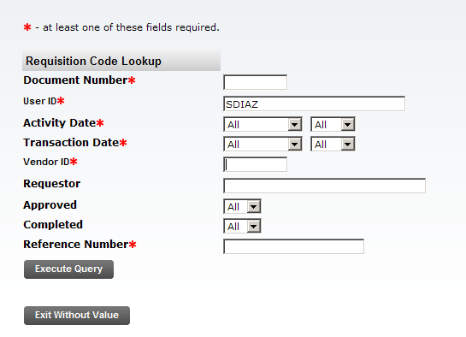

- Click a Document Number to select and view the document, click the Exit without Value to return to the View Document page, or click the Another Query icon to return to a (blank) Document Lookup page.
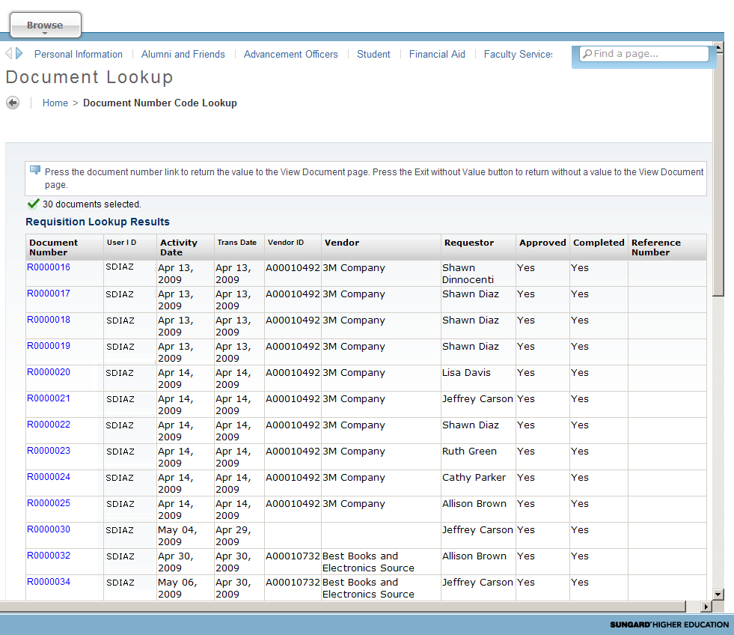

Performing a Budget Transfer
SSB-Finance allows a user to process Budget Adjustment Journal Vouchers on the Web. This form enables the Web user to transfer budget from one FOAPAL to another. The form does not allow completion of documents using rule classes that are not self-balancing.
A budget transfer requires:
- fund/organization security
- rule class security
- available budget
- must be within same chart
- account field must contain the budget pool accounts

The Budget Transfer will be used when making a budget transfer between budget line items within a fund.

Steps to Complete this Process:

- Click on Budget Transfer from the Finance menu to navigate to the Budget Transfer Page.

- Enter appropriate parameters, or retrieve an existing template by selecting it from the Use Template drop-down menu and clicking the Retrieve button.

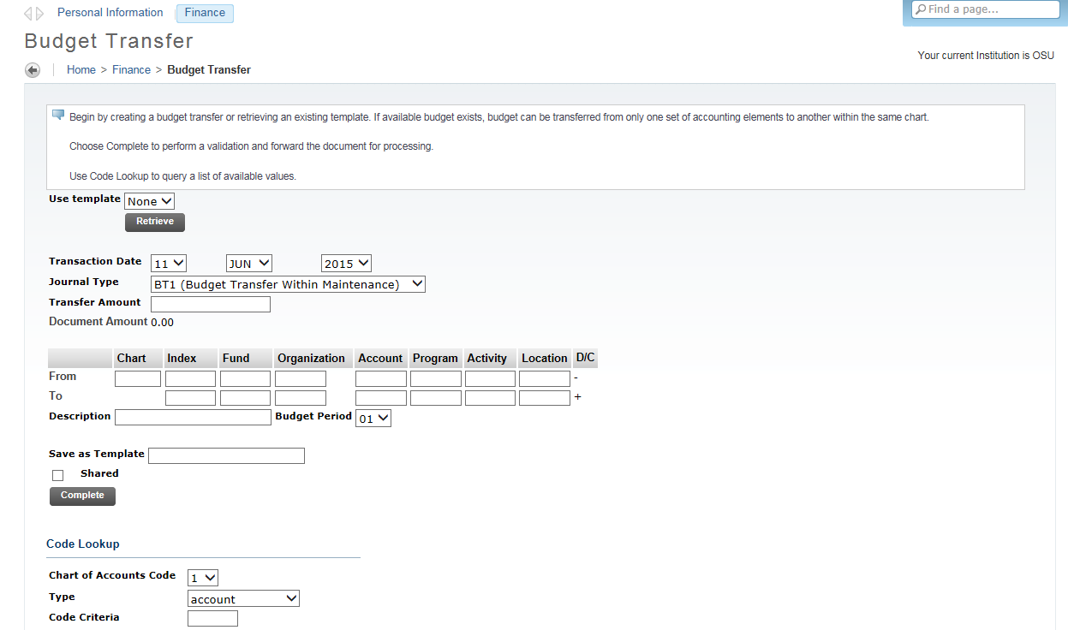

- Click the Complete button to execute your budget transfer.

Performing a Multiple Line Budget Transfer
The Multiple Line Budget Transfer Form is the same as the Budget Transfer Form except that it allows Budget transfers between up to five FOAPALs. The fields on these forms are identical.
In each document created, the pluses (transfers to) must equal the minuses (transfers from). These amounts must offset one another and add up to the Document Amount.
The rule classes that we provide for the budget transfers are BT1 (Budget Transfer within Maintenance), BT2 (Budget Transfer on Labor Accounts), BT3 (Budget Xfer-Xfunds Req Approval), and BT4 (Research Budget Xfers-Req Approval). These are hard-coded in the form. Discuss the appropriate use of these designations with your budget personnel.
This form is not meant to allow completion of documents using rule classes that are not self-balancing.

Steps to Complete this Process:

- Click on Multiple Line Budget Transfer from the Finance menu to navigate to the Multiple Line Budget Transfer Page.
- Enter appropriate parameters, or retrieve an existing template by selecting it from the Use Template drop-down menu and clicking the Retrieve button.

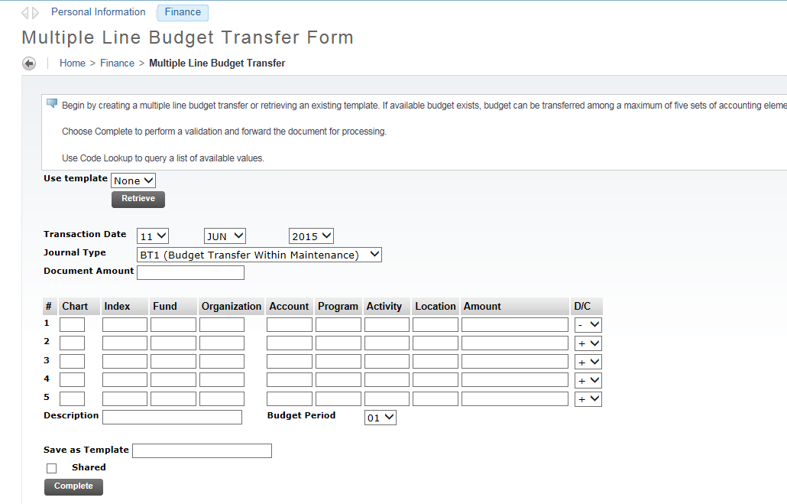

- Click the Complete button to execute your budget transfer.

Delete Finance Template
Delete Finance Template is an option on the Finance Menu that enables a user to delete templates or queries. This can be helpful when a template is renamed and the original needs to be deleted. The ability to delete templates depends on the privileges associated with your user ID.
- If you are Finance User assigned the Finance Data Tailor Role, you can delete both your own and others’ templates or queries, both shared and personal.
- If you are a Finance User not assigned the Finance Data Tailor Role, you can delete only your own, personal templates or queries.

Steps to Complete this Process:

- Click on Delete Finance Template from the Finance menu to navigate to the Delete Finance Template.
- Enter in the Template/Query Name and Template/Query Type.
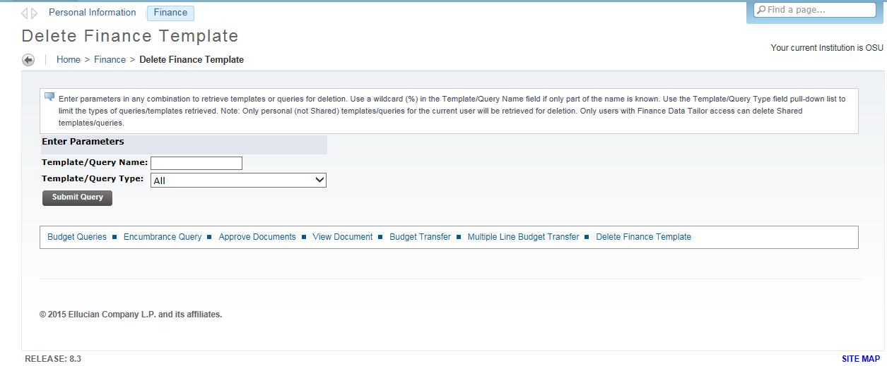
- Delete checkbox of the items to be deleted.
- Click the Delete button.

