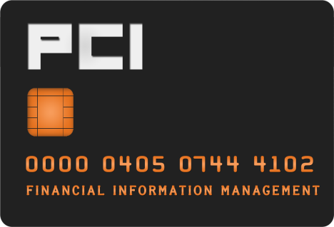
Credit Card Terminal Request Form

Email completed form with approval signature to merchantservices@okstate.edu.

REQUESTOR INFORMATION
NAME: | EMPLOYEE EMAIL:
MERCHANT NAME: | CAMPUS ADDRESS:
TELEPHONE NUMBER:

Select campus:
☐OSU - Stillwater ☐ OSU – CHS
☐OSU - Tulsa

Select one option:

Banner Chart/Fund for lease fee: Click here to enter text.
Banner Chart/Fund for monthly fee: Click here to enter text.

Lease Agreement
All credit card equipment must be obtained through Merchant Services in the Office of Financial Information Management (FIM). Equipment will be leased to the department while a merchant number is active. All transaction activity will be performed in compliance with the PCI DSS and OSU Policies. Upon deactivation of merchant account or replacement, all equipment must be returned to Merchant Services.

APPROVED (Director/Dept. Head)

Signature & Date

Date Submitted: ________________________________ Merchant Number: ________________________________
Date Ordered: _________________________________ Terminal ID Number: ______________________________
Terminal Delivery Date: _________________________ Terminal Serial Number: ___________________________

___________________________________________________________
Merchant Services Use Only Signature & Date

