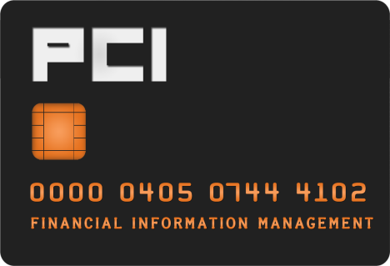
Merchant Account Request Form

Complete form, obtain approval signatures, and email to
merchantservices@okstate.edu.

After form is received, you will be contacted regarding your request.

Please call Andrea at 405-744-4102 with questions.

Merchant Information

Merchant Name: (24 characters including spaces)
Business Address:
Phone Number:
Fax Number:

Customer Service Contact Name:
Customer Service Email:

Organization Name/Number:

Purpose of Account:
i.e.: ticket sales, applications, conference or seminar registrations, etc.

Web Site Address:
(For e-Commerce application only- web site where you will be doing business. Disregard if using uStore)
(be sure to include HTTP:// or HTTPS:// in your web site address)

Card Brands Accepted:

Type of Processing:

Equipment Information: (for In-Person or (MOTO) Mail/Telephone orders)

Transaction Information:

% of transactions swiped:
% of transactions MOTO: (mail order/telephone order)
% of transactions online:

Average Ticket Amount: (in dollars) Estimated
Annual Outlet Volume: (in dollars) Estimate for the year

Business Track Enrollment:
-this person will enroll for online access to reports and to respond to disputes

Contact Name:
Contact Email:

Expenses

Banner Chart and Fund for Processing fees:

Requestor Information

Requestor Name:
Requestor Phone Number:

Approval Signatures

Fiscal Officer Name:
Fiscal Officer Signature: Date:

Department/Director Name:
Department/Director Signature: Date:

PCI Officer Name:
PCI Officer Signature: Date:

