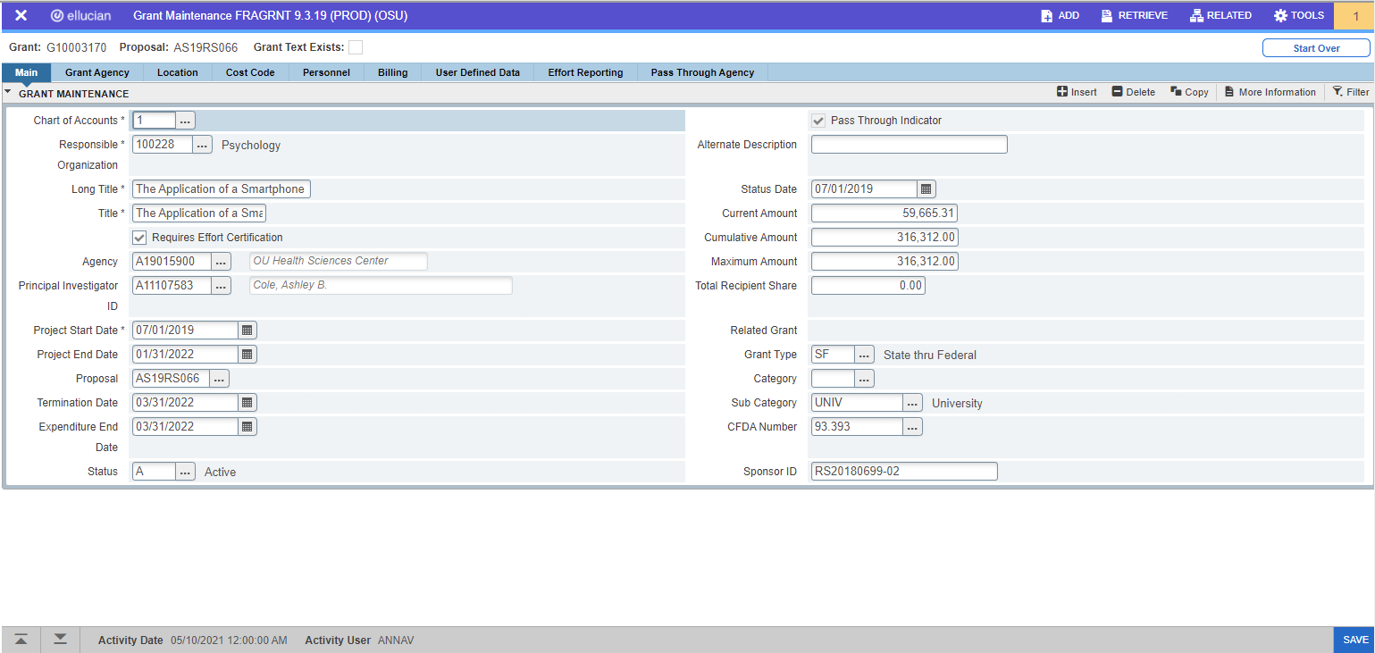

-Review all items on Main tab on FRAGRNT and make sure they were entered correctly
-Click on the More Information button in the top right

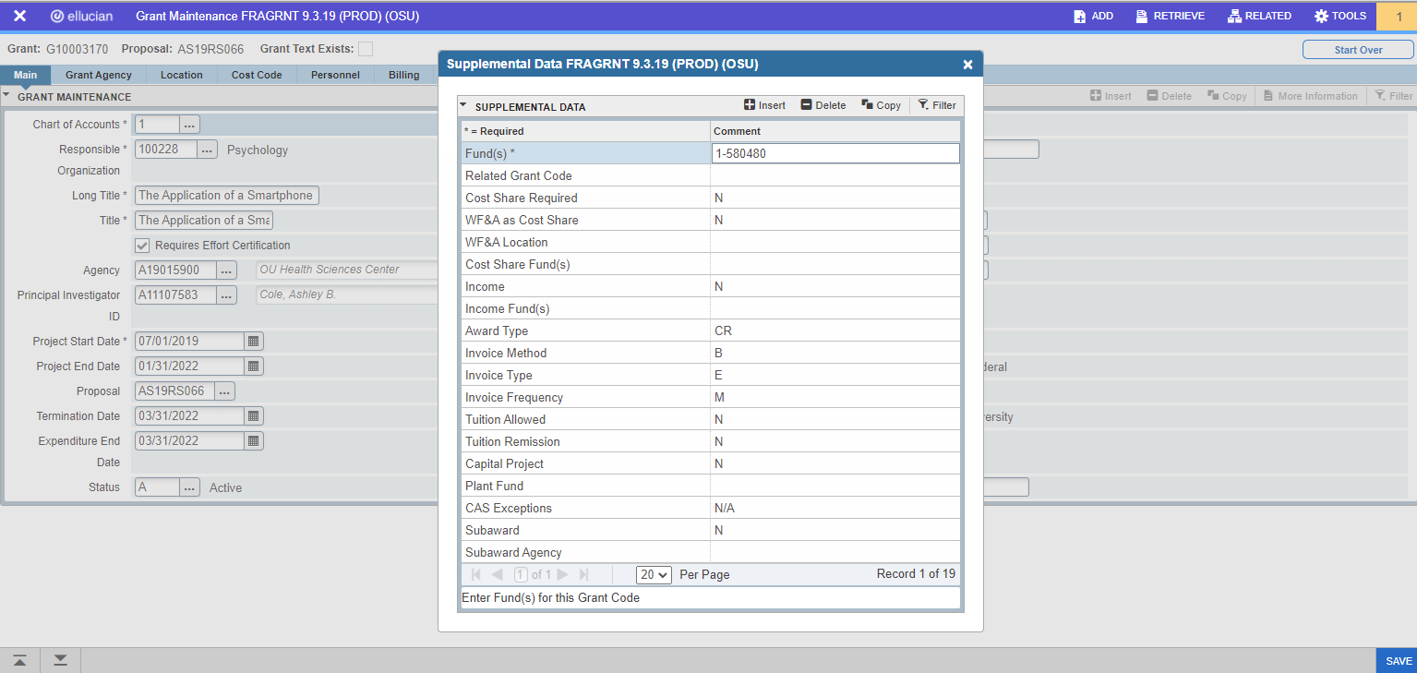

-Fill in all relevant information into the More Information tab (Some fields have restrictions as to what you can put in them and some fields can have multiple lines by pressing the Copy button at the top of the form.

-Press SAVE once all information is completed

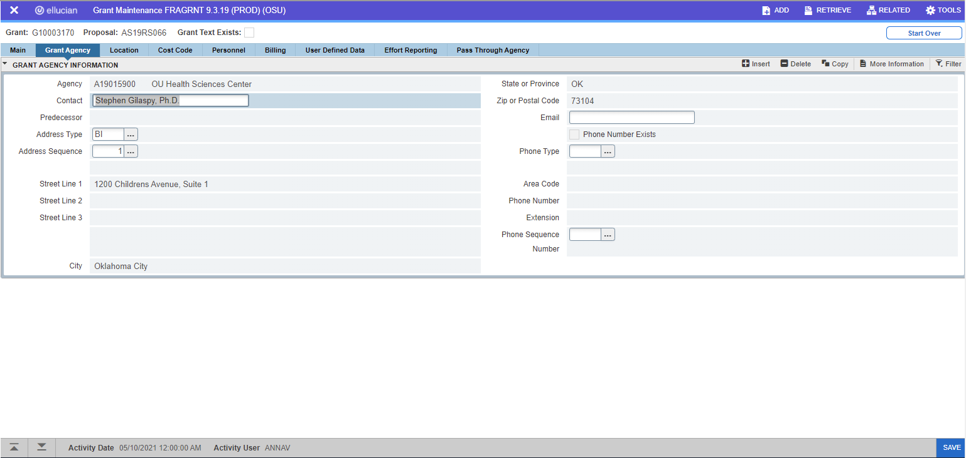

-Confirm that the Grant Agency is correct. You may have to click on the Address Type to select the correct Billing Address
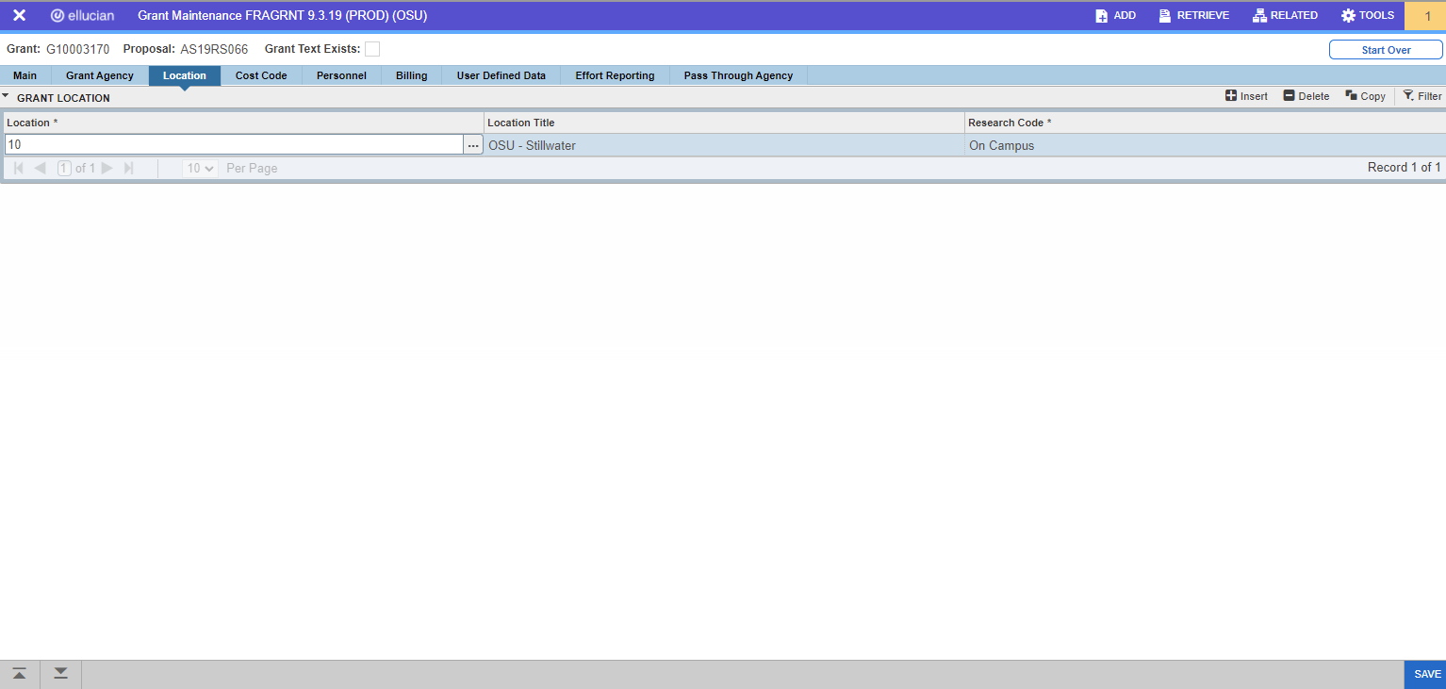

-Location should be the campus the work will be done on

-Research Code should state whether the work is being done On or Off Campus

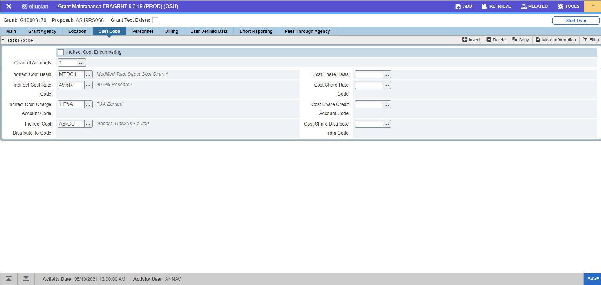

-Confirm information on the Cost Code tab, keeping in mind that this is just informational. Actual Indirect Cost information is entered on FRMFUND by individual fund

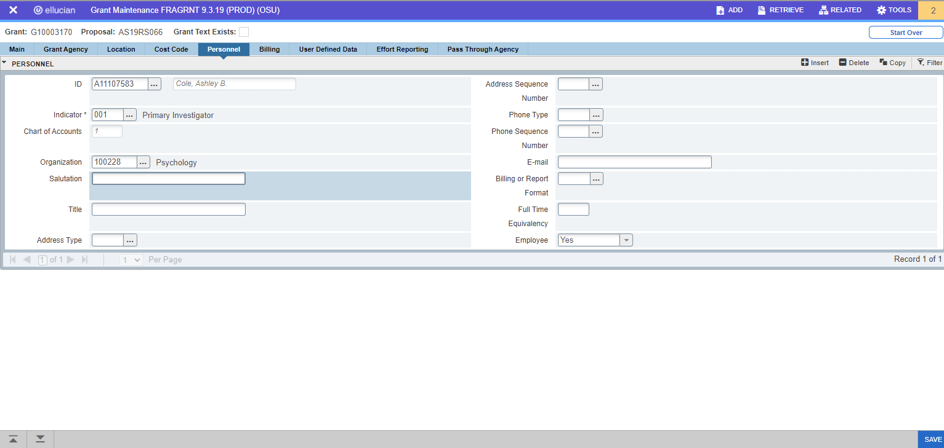

-Confirm that PIs are entered correctly. Award can have multiple PIs.

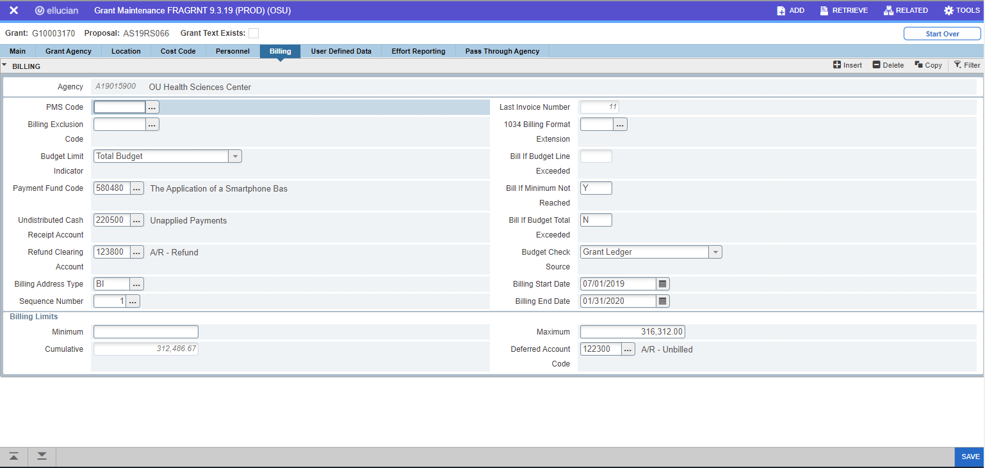

-Confirm that the information on this screen is correct. Paying close attention to:
-Undistributed Cash Receipt – 220500
-Refund Clearing Account – 123800
-Deferred Account Codes - 122300

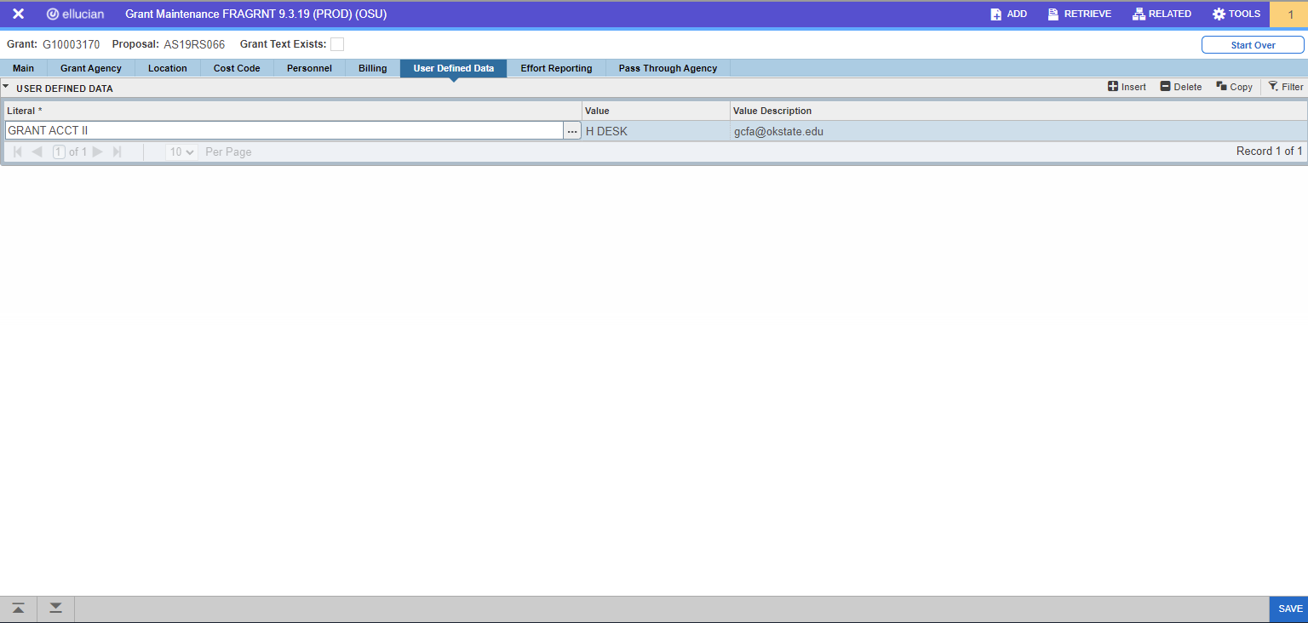

-Confirm that the correct Desk Code was entered into the page

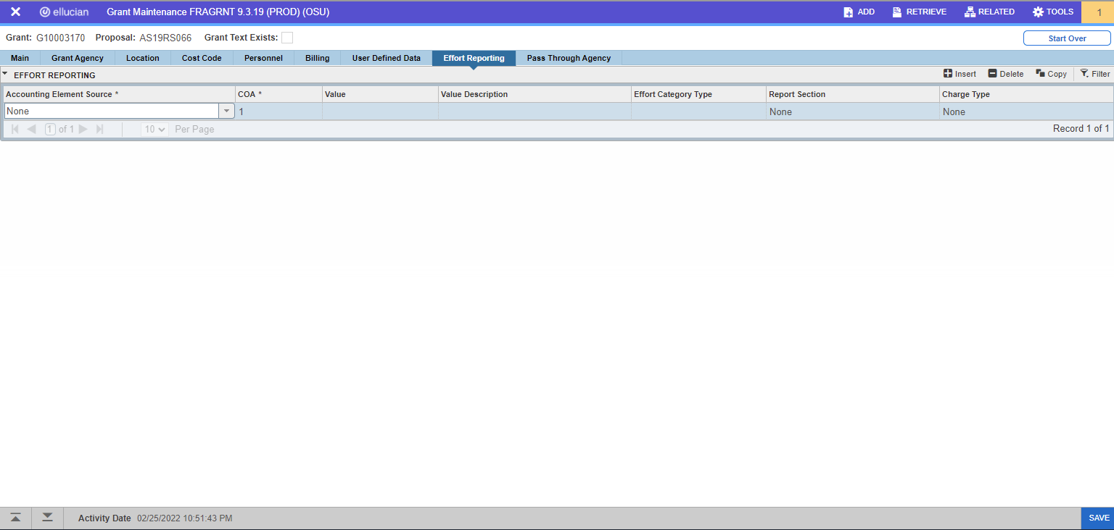

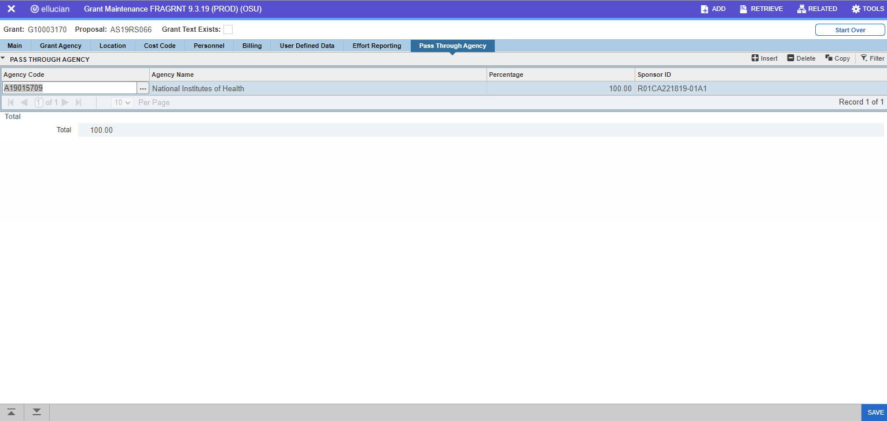

-Confirm information on the Pass-Through Agency tab. If Sponsor ID is not included work with Agency to obtain the correct number.

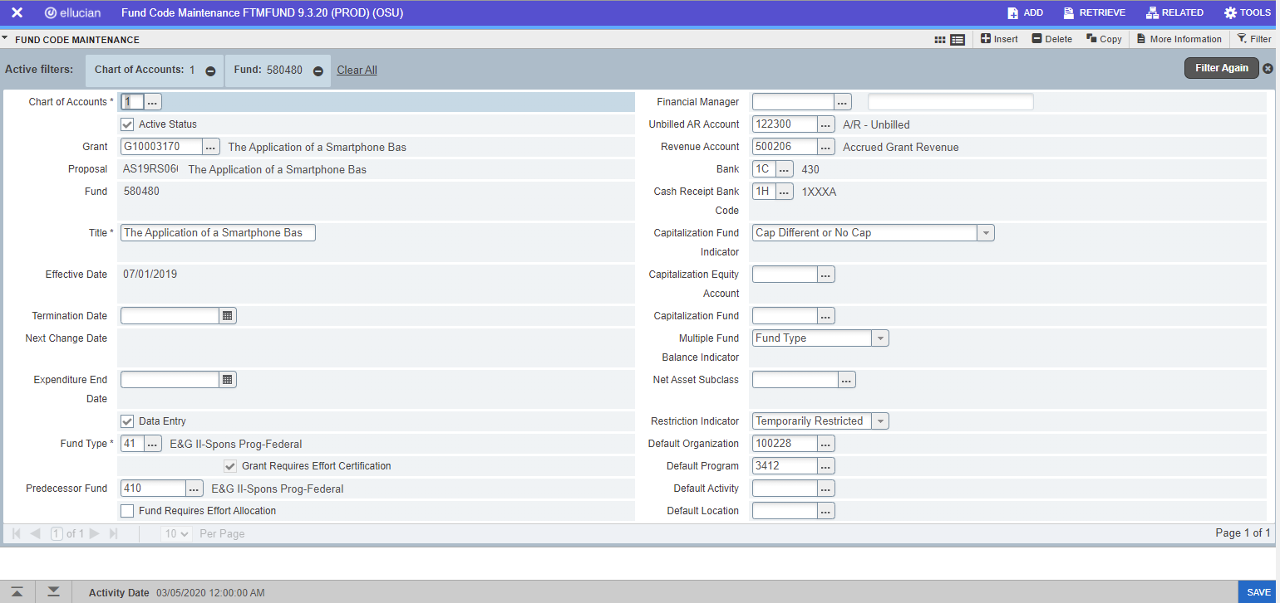

-Confirm FTMFUND information is correct paying close attention to the following fields:
-Fund Type – Make sure it matches what the primary Grant Type is on FRAGRNT as Federal/State/Private
-Default Program – Make sure that it is properly coded as Research/Instruction/Extension

*Grant Accountants cannot edit this screen, so any corrections need to go to the person who set the fund up.

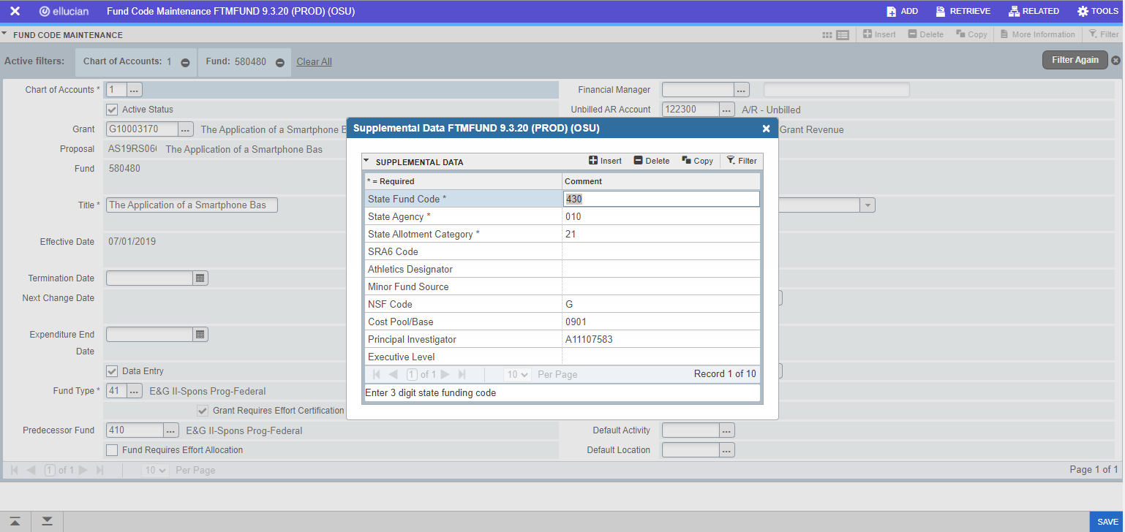

-Confirm that there is information listed in the More Information tab. If any of these fields are missing, please report to the person that set the fund up to get it corrected (NOTE: NSF Code only needs to be entered if the program of the fund has a research purpose (Program Code starts with 34)

*Grant Accountants cannot edit this screen, so any corrections need to go to the person who set the fund up.

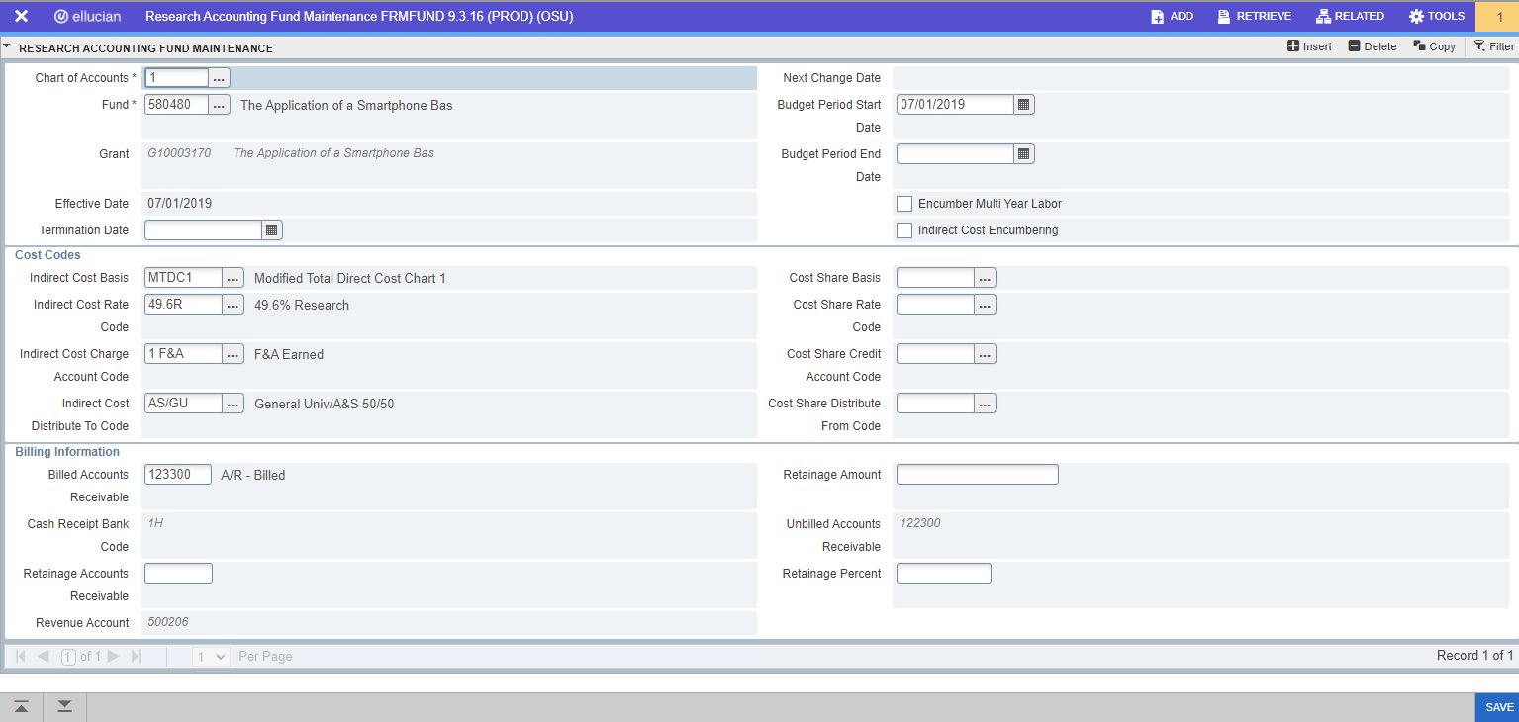

-Confirm that the information is entered correctly. Paying attention to the Cost Codes for Indirect Costs.

*Grant Accountants cannot edit this screen, so any corrections need to go to the person who set the fund up.

