Payroll Workers Compensation (WC)
Payroll Services Practice 10-3005.0 6/17/2024

- General Information
OSU provides WC coverage for all employees for work-related injuries or illnesses. OSU Human Resources department manages the WC process including all procedures and training related to eligibility and coverage. When an injury occurs, procedures located at https://hr.okstate.edu/consulting-services/absence-and-leave/work-comp.html should be followed.
The first three full working days, following the date of injury and the employee is seen by UHS, is considered the waiting period. The employee is responsible for the three-day waiting period (either using accrued leave or leave without pay).

The OSU’s third-party administrator, will pay for a portion of qualified absences as required by Oklahoma statute. OSU Policy allows employees to supplement OSU’s third-party administrator payments with accrued sick and annual leave up to the total amount of the employees regular bi-weekly or monthly pay. This policy details the steps necessary to generate payroll payments to the employee to supplement the payments from OSU’s third-party administrator and ensure the employee continues to receive leave accruals in accordance with leave policies for time worked or in a paid status.

This practice applies to both temporary total disability (TTD) and transitional duty program (TDP) coverage. This practice does not apply bi-weekly employees on TDP for a period of greater than 40 hours in the pay period. In this instance leave should be claimed on the timesheet as calculated on the TTD/TDP spreadsheet.

Employees will need to be put on leave without pay with benefits (LWOP-B) through the electronic personnel action form (EPAF) system. Each payroll, the department will submit a request to pay the employee to make them whole when added to the payments from OSU’s third-party administrator.

Leave charged will use the earnings code WCL which will apply first to sick leave balances then annual leave if no sick leave remains.

Monthly paid employee’s payments will include an estimated portion due to the timing requirements for the forms to be submitted. This should be corrected on the next supplemental payroll.

- Setting up the Employee Before Payments Start
To setup the employee for payroll payments, the following steps must be completed:
      - Follow all instructions at https://hr.okstate.edu/consulting-services/absence-and-leave/work-comp.html.
      - Enter an EPAF Change Existing Job
        - Action Date = Day WC starts (after the 3 day waiting period). NOTE: If the action date is limited by the last paid date and cannot be entered as the action date as the 4th working day after the injury, the employee may be overpaid for the period from the action date to the end of the last paid date. See Payroll Services Practice 20-1001 Underpayments and Overpayments for more information.
        - Personnel Date = Day WC starts (after the 3 day waiting period).
        - Job Status = LWOP-B for the first day after the 3 day waiting period.
        - Job Change Reason = LWC, Leave Workers Comp
        - Leave Report Method (monthly) = none or Time Entry Type (bi-weekly) = Payroll Time Entry
      - The employee should NOT submit a leave report or timesheet for any pay period in which they are collecting WC. No action is required by the employee if they do not have any hours worked in the pay period.
      - Departments may request an exception to the requirement to enter the EPAF or set the leave report method (monthly) to none or the time entry type (bi-weekly) to payroll time entry from the Director of Payroll Services. In this instance, a copy of the approval should be attached to the pdf when emailed to payroll.services@okstate.edu.

- Paychecks
Complete the TTD/TPD Spreadsheet located at https://hr.okstate.edu/consulting-services/absence-and-leave/work-comp.html. If you do not have the AWW, email workerscomp@okstate.edu. Complete all fields through the current pay period. For any periods where the employee is expected to return to work, enter 40 hours in the hours worked column and zero in the full calendar days missed. Any questions related to this spreadsheet should be directed to the workerscomp@okstate.edu. For monthly paid employees, the spreadsheet should be completed for the full month. Include estimates for entries from the 16th to the end of the current month.
The 10-3005.2-Worker’s Compensation Request for Pay Forms Spreadsheet should be used to generate the paycheck and leave accruals for the employee. The TTD/TPD Spreadsheet must be completed for all weeks in the pay period.
  - Monthly Paid Employees
        - 16th of the month (or next business day) regular monthly payroll
- The MTHLY tab – Monthly Paid Employee Workers Compensation Request to Pay Form is used for monthly paid employees.
- No leave claims should be submitted for leave after the start of the WC. Careful review of the first leave report in which the employee is in WC should be reviewed. No leave should be reported after the start of WC.
- Follow the instructions on the form to enter all yellow highlighted information from the TTD/TPD Spreadsheet.
- Enter the employee’s hourly rate from Banner.
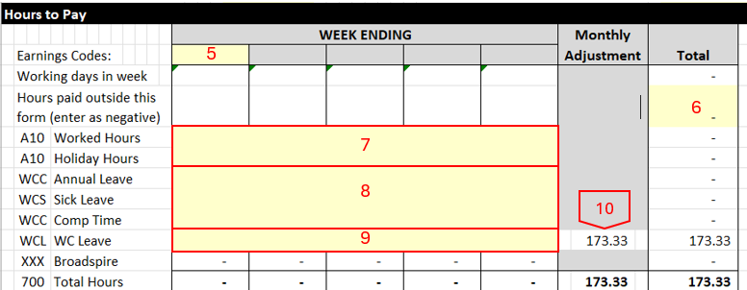
- List all weeks ending in the month.
- Hours Paid Outside this Form (enter as negative) - Enter total hours for the month that will be paid in addition to this form. This would include hours for days in the month prior to setting the employee on LWOP or after returning the employee from LWOP.
- A10 Worked Hours - Record Worked Hours each week from Column C of the TTD/TPD Spreadsheet-Hours Worked. This should include hours paid outside this form (see #6 above).
- 150-Holiday, WCC Annual Leave, WCS Sick Leave, and WCC Comp Time - Split out Leave Not Associated with WorkComp hours reported on Column D of the TTD/TPD Spreadsheet.
- WCL WC Leave - Enter Leave to Report from Column H of the TTD/TPD Spreadsheet.
- Review the Monthly Adjustment. This is related to the conversion of weekly to monthly pay and should be minimal (less than 10 hours).
- Monthly Salary Verify – XXX Broadspire - Enter the weekly Broadspire amount from Column G of the TTD/TPD Spreadsheet-Broadspire Payment
- Total hours should be 40 times employee FTE for all weeks listed. If there is a week when the amount is off slightly (+/-.02), adjust the WCL leave.
- Verify total salary
- Obtain signatures from supervisor and employee (if hours worked are reported).
- Email the form and the TTD/TPD Spreadsheet as a pdf file to payroll.services@okstate.edu include the Banner ID-Employee Name – WC Pay Request and pay period in the subject line no later than the 16th of the month (or next business day).
        - End of the month - supplemental payroll
- Review all estimated entries from the monthly payroll.
- Submit adjustments on the MTHLY tab – Monthly Paid Employee Workers Compensation Adjustment Form Estimated to Actual Form.
- Enter the highlighted information including
- original hours paid (from the Monthly Paid Employee Workers Compensation Request to Pay Form submitted on or around the 16th of the month).
- Update the TTD/TPD Spreadsheet and use it to complete the corrected hours to pay.
- Obtain signatures from supervisor and employee (if hours worked are adjusted).
- Email the form and the original TTD/TPD Spreadsheet and the corrected TTD/TPD Spreadsheet as a pdf file to payroll.services@okstate.edu include the Banner ID-Employee Name – WC Estimate Adjustment and pay period in the subject line no later than supplemental payroll published deadlines.
  - Bi-Weekly Paid Employees
        - The BWKLY tab – Bi-Weekly Paid Employee Workers Compensation Request to Pay Form is used for bi-weekly paid employees.
        - No timesheet information should be submitted for time after the start of the WC. Careful review of the first time period after the start of WC is critical to ensure no time or leave is reported after the start of WC.
        - Follow the instructions on the form to enter all yellow highlighted information from the TTD/TPD Spreadsheet.
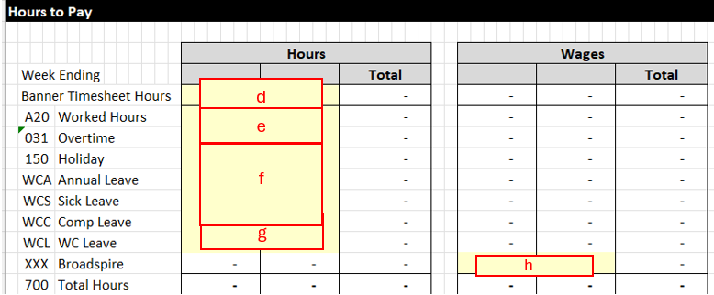
        - Banner Timesheet Hours - Enter total hours reported on a submitted and approved electronic (Banner) Timesheet for each week. This is hours that will be paid from the timesheet in addition to this form. Attach the timesheet.
        - A20 Worked Hours - Record Worked Hours each week from Column C of the TTD/TPD Spreadsheet-Hours Worked.
        - 150-Holiday, WCC Annual Leave, WCS Sick Leave, and WCC Comp Time - Split out Leave Not Associated with WorkComp hours reported on Column D of the TTD/TPD Spreadsheet.
        - WCL WC Leave - Enter Leave to Report from Column H of the TTD/TPD Spreadsheet.
        - XXX Broadspire – Enter the weekly Broadspire amount from Column G of the TTD/TPD Spreadsheet-Broadspire Payment
        - Total hours should be 40 for all weeks listed. If there is a week when the amount is off slightly, adjust the WCL leave.
        - Obtain signatures from supervisor and employee (if hours worked are reported).
        - Email the form and the TTD/TPD Spreadsheet as a pdf file to payroll.services@okstate.edu include the Banner ID-Employee Name – WC Pay Request and pay period in the subject line no later than the Monday following the last day of the pay period (or next business day).
- Returning the Employee from WC
  - Full Duty
        - Enter an EPAF Change Existing Job
        - Action Date = Day WC ends and the employee returns to full duty. NOTE: If the action date is limited by the last paid date and cannot be entered as the day the employee returns to full duty, the employee may be underpaid for the period from the action date to the end of the last paid date.
        - Personnel Date = Day WC ends and the employee returns to full duty.
        - Job Status = Active
        - Job Change Reason = LWCR, Leave Workers Comp Return
        - Leave Report Method (monthly) = Leave Report on the Web or
Time Entry Type (bi-weekly) = Pay Period Timesheet (Banner) or none for third party time.
        - Careful review of the first timesheet or leave report after the employee has returned to regular duty is critical. If the employee is unable to enter time or leave for the pay period, a manual timesheet and ENP (bi-weekly paid employees) or leave adjustment (monthly paid employees) should be submitted.
  - Leave of Absence/Long-Term Disability
        - Enter an EPAF Transfer to Salary Job
        - Action Date and Personnel Date = Day WC ends and long-term disability begins
        - New Position Number = 000002

- References
This payroll services practice is intended to comply with OSU policies and procedures as well as federal and state laws and rules. Specific guidance may be found at OSU policies 3-07770 Worker’s Compensation and Payroll Services Practice 20-1001 Underpayments and Overpayments.

