When to Call the Agency Support Team:
- Complex Itineraries: If your travel involves multiple flights, airlines, or connections.
- Rebooking Assistance: For help rebooking flights, especially if you need to consider alternative routes or airlines.
- Special Requests: For special requests or accommodation (e.g., meal preferences, seating arrangements) that need to be carried over to new bookings.
- Urgent Changes: When you require immediate changes to your travel plans and need expert advice on the best options available.
- General Support: For any general inquiries or support related to your trip disruption.
When to Call the Airlines Directly:
- Immediate Flight Information: For real-time updates on flight status, delays, or cancellations.
- Currently at the Airport. If you have any needs and are currently checked in and/or at the airport, locate the nearest airline representative, they are required to help you when you are at the airport.
- Check-In Issues: If you encounter problems during the check-in process or need to confirm your check-in.
- Baggage Problems: For lost, delayed, or damaged baggage inquiries.
When to Use the Airlines Mobile App:
- Immediate Flight Information: For real-time updates on flight status, delays, or cancellations, all updated information can be quickly found on the airline’s app and/or TripIt.
- Gate Changes: To confirm gate changes or boarding times, especially for tight connections.
- Flight Status Confirmation: To verify the status of your flight, especially during bad weather or other disruptions.
- Onboard Services: If you have questions or issues related to in-flight services and amenities.
- Same Day Standby: Most of the major airlines will allow you to request same day standby via the mobile app.
General Tips:
- Keep Contact Numbers Handy: Ensure you have both the agency support team’s and the airline’s contact numbers readily accessible. Anthony Travel: 405-446-8627 and Anthony Travel After Hours: 800-526-8245
- Stay Calm and Polite: Maintaining a calm and polite demeanor can often lead to more efficient and effective assistance.
- Document Everything: Keep a record of your communications, including names of representatives you speak with, times, and details of the conversation.
- Use Mobile Apps: Many airlines offer mobile apps with features for real-time updates, rebooking options, and direct communication channels.
- Remain On Hold. During ground stoppages or other massive events, hold times may be longer than normal. Please remain on hold, as calls are answered in the order they are received. If the call is not an emergency, please call back during the next business day.
- Review Remarks on Itinerary. The remarks section is consistently filled with useful information, including contact details. Here is an example of remarks on an itinerary:
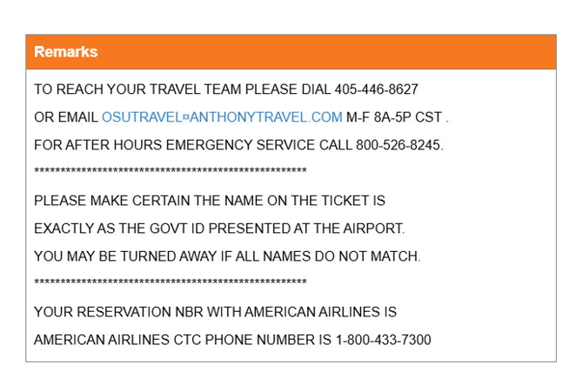
By following these guidelines, you can ensure a smoother process during trip disruptions.

